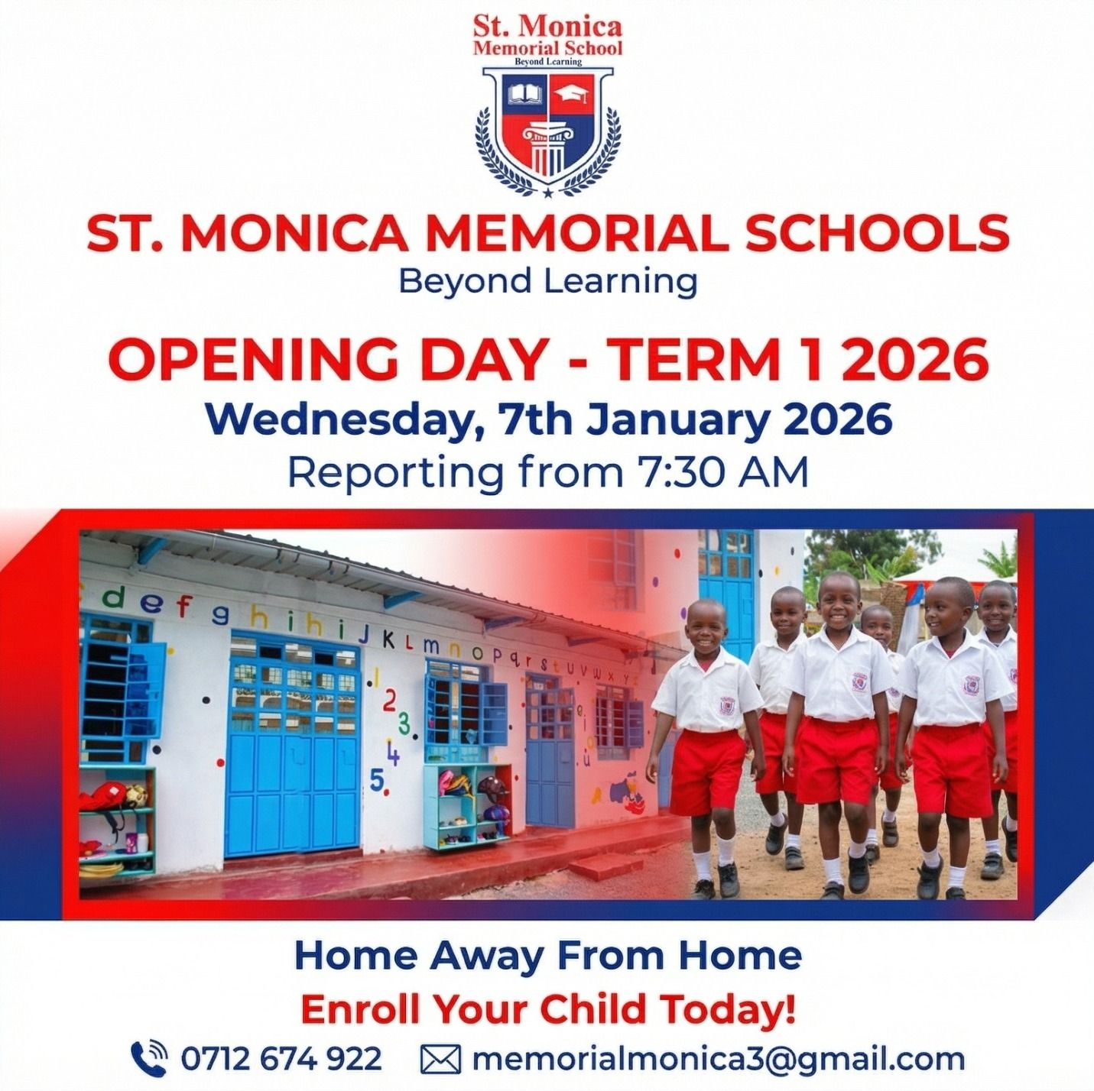

Parent Communication & Complaints Policy

Introduction
This policy sets out the approach of St Monica School (SMMS) to maintaining open, effective and respectful communication between parents/legal guardians and the school, and provides a clear procedure for resolving concerns and complaints.
It has been developed in consultation with staff, parents, and the Board of Management (BoM) and is informed by Education Act 1998 (Section 28), the Children First Act 2015, and the revised parental complaints procedure agreed by the Ministry of Education and Management bodies of Primary and Special Schools.
The aim is to ensure that concerns are addressed fairly, promptly, and in the best interest of the child while preserving the important partnership between parents and the school.

Aims
- Promote respectful, collaborative communication between home and school.
- Provide clear channels for parents to seek information or raise concerns.
- Outlines a staged process of resolving complaints efficiently and transparently.
- Support the well-being of staff and families through respectful interactions.

Roles and Responsibilities

Parents / Legal Guardians
- Communicate respectfully and constructively with school staff.
- Use official school communication channels for queries or concerns (Email / phone call).
- Raise issues in timely manner to facilitate early resolutions.
- Refrain from making public or social media comments that could harm individuals or the school.
- Respect the decision-making authority of the school's Board of Management.

School Staff
- Provide timely and accurate information through approved channels (letters, email, phone).
- Respond to inquiries within five (5) working days where possible.
- Facilitate regular structured meetings (Parent-Teacher, PPP meetings).
- Ensure compliance with school and safeguarding requirements.
- Maintain a safe and respectful environment for all interactions.

Communication Procedures

Formal Communication
- Parent-Teacher Meetings / Personal Pupil Plan (PPP) Meeting: Scheduled as needed.
- Annual completed PPP: Sent to parents who request.

Informal Communication
- Email: Primary method for non-urgent matters.
- Telephone: For urgent updates or appointment scheduling.
- In-person Meetings: By prior arrangement only and one week in advance where possible.

Social Media Guidelines
- Avoid posting comments about staff, students, or school policies online.
- Use official school channels for concerns.
- Do not share photos or videos from school events without permission.

Complaints Procedure
The school follows the Revised Parental Complaints Procedure (effective 24th May, 2026). Complaints must relate to the education and welfare of the complainant's own child.

Stage 1 - Informal:
- Parent meets with the teacher to discuss and seek resolution.
- If unresolved, parent meets with the Principal or Deputy Principal if the complaint is in relation to the behavior care needs of the student.
- If still unresolved, parent can write to the chairperson of the BoM.

Stage 2 - Formal Written Complaint:
- Parent submits a signed letter/email to the Chairperson of the BoM.
- Chairperson provides a copy to the teacher and seeks to resolve the matter within 10 school days.

Stage 3 - Board of Management Review:
- If unresolved, the chairperson makes a formal report to the BoM within 10 days of receiving the written complaints.
- BoM may conclude the matter or proceed to a hearing following the national procedure.

Stage 4 - Decision:
- BoM issues a written decision with 5 school days of the final meeting.
- The decision of the BoM is final.

Conflict Resolution & Conduct
The school encourages mediation where appropriate.
- Aggressive or harassing behavior will not be tolerated and may result in restricted communication methods.

